Foraging ants The tale of the trail

The foraging behaviour and colony structure of ants has been attracting researchers’ attention for a very long time. Some ant species, like *Lasius niger*, forage randomly to find a food source. Upon doing so, they return to their colony while leaving a pheromone trail. When other foragers find such a trail, they can follow it, reinforcing the path if they find food by depositing new pheromones on the trail (**positive feedback**). As pheromone trails evaporate over time, shorter paths are being reinforced more frequently due to faster travel times. This **evaporation of the pheromones** forming the trail is important, as it prevents convergence on suboptimal solutions and encourages exploration. This system to optimize foraging, the result of evolutionary processes, has even inspired computer scientists coming up with so-called ‘Ant colony optimization algorithms’.

Figure 1: DALL-E interpretation of foraging ants in the context of Computational Biology

As this is a complex system with many parameters, intuitively answering questions about ant ecology can turn out to be quite tricky. Therefore we will need to make an ecological model in which we simulate the environment and the interactions of the ants. To do this, we will use agent-based modelling (ABM). This is a powerful tool in ecological and computational biology contexts. It involves simulating the interactions of individual agents (such as organisms, cells, or even molecules), to observe how complex system-level behaviours emerge.

To make this model, you will have to create an ‘**arena’** in which ants can forage. Assume a **rectangular grid which has a central starting point** (the colony; make this bigger than just once grid cell) and contains **randomly distributed food sources**. These food sources have different nutritional values and disappear when depleted (to keep the total food availability in the arena equal, a new source will randomly appear). Next, you will have to create your ants and of course a function(s) to simulate each foraging step an ant will take (‘random walk’, pheromone sensing and relative chance function, food source reached, return to colony with pheromone trail, exponential function for decay of pheromones, diffusion of pheromones...). Repeat this function for each ant in each step to conclude one round. By repeating many foraging rounds, we can simulate the total foraging.

# Questions:

* Is there a benefit of social foraging compared to individual foraging (without pheromone trails)? 🡪 STATS
* Does the level of food abundance and quality play a role in this? Imagine a total food availability of 100, compare, for example, between **25 sources of value 4 or 4 sources of value 25**.
* What is **the effect of the number of ants** on the colony fitness? Is there a minimal colony size to benefit from the pheromone trail foraging system?
* Is there an **effect of arena size** on the effectiveness of this system?
* Visualize the pheromone trails with a heatmap showing the pheromone levels of each cell in the arena at the end of a simulations. Extra: it would be cool to plot the pheromone levels in the arena as a gif to see the changes in time...

Met en zonder feromoon 4x25

Met en zonder feromoon 4x25 ⬄ 25x4

Met en zonder 4x25 met 10 mieren ⬄ 50 mieren

Met en zonder 4x25 met 10 mieren grid 10x10 en grid 50x50

# General tips:

* Reading tip: *Trail Pheromones: An Integrative View of Their Role in Social Insect Colony Organization* (<https://doi.org/10.1146/annurev-ento-010814-020627>)
* Avoid hardcoding parameters, as you have to be able to easily play around with them (e.g., arena_size, resource_abundance, resource_quality amount_ants, foraging_rounds, replicates, evaporation_rate,...).
* When selecting parameters, try to relate to the natural situation by looking at literature, but sometimes you will have to simplify things and/or make assumptions. Explain your choice in the report.
* Visualize what is happening: print your arena with hive and food sources, try to show the foraging path of one ant,... This can prove very helpful in evaluating the model functionality.
* Start small (e.g., arena 15x15 with only 3 ants) so that computation goes fast, and scale it up when you find that the model is functioning well.
* Do many simulations and take the average. The more the better, but see what is computationally feasible.
* Export the data you generate. This way you can also divide the computing over your different laptops (e.g., in stead of running 100 replicates on 1 computer, you can run 25 replicates on 4 computers) and then later merge the data for analysing.

Figure 2: hypothetical view on a 15x15 arena with a central anthill, different food sources, and foraging ants.Pheromone trail in purple, foraging path in dashed lines.

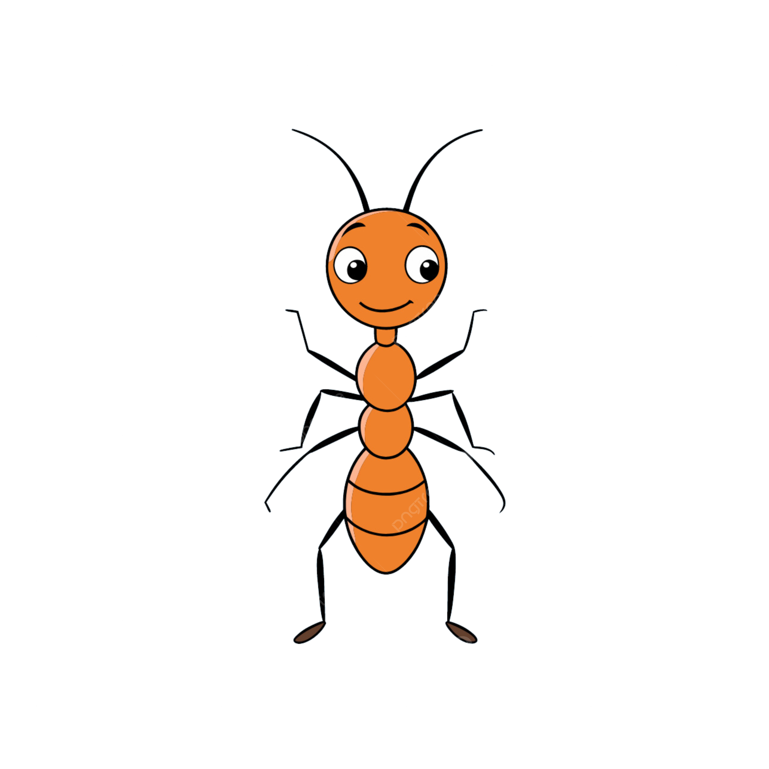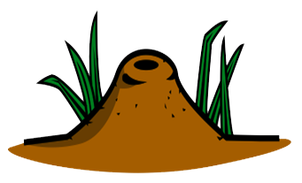

**10**

**5**

**2**

<https://www.netlogoweb.org/launch#https://www.netlogoweb.org/assets/modelslib/Sample%20Models/Biology/Ants.nlogo>